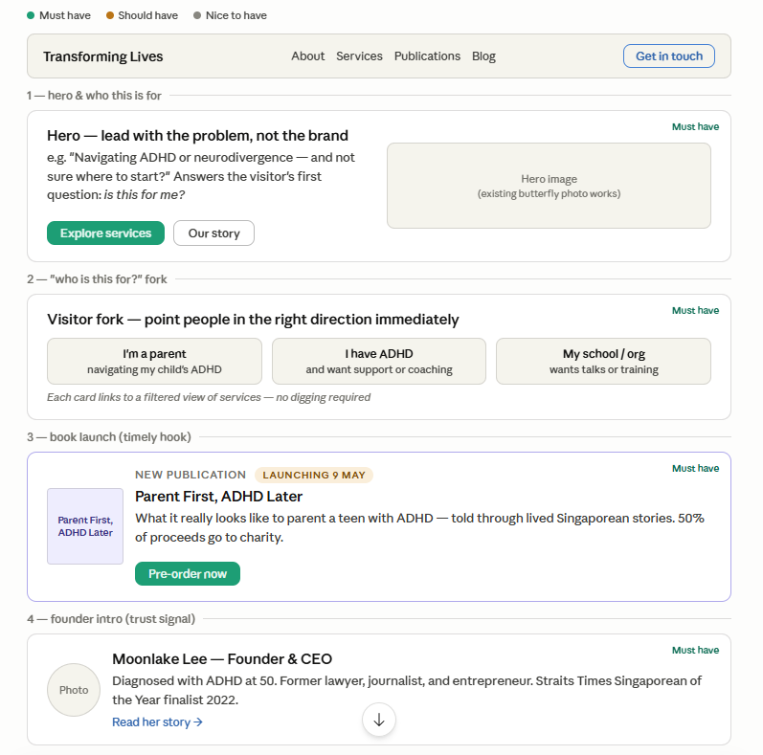
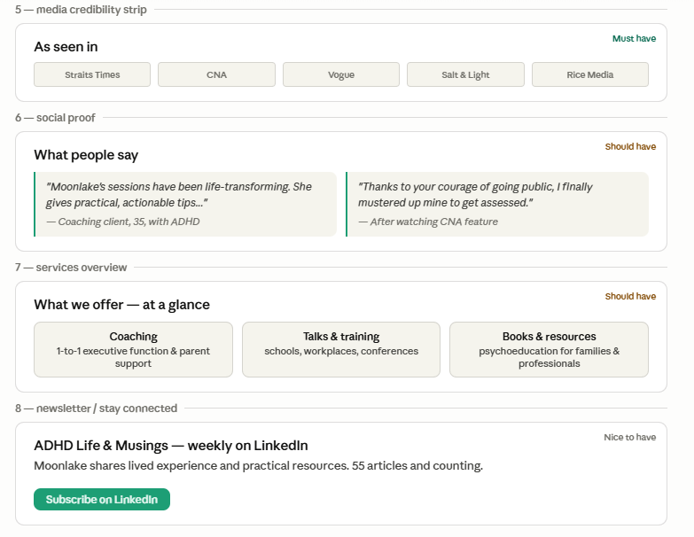
1. Hero wording
The headline is the most important line on the site. Think of it like the first sentence of a conversation — it should make the visitor feel seen before anything else.
Option A — Lead with the person, not the service:
"Life feels harder than it should. We can help you understand why."
Option B — Name the audience directly:
"For families, individuals, and organisations navigating ADHD and neurodivergence."
Option C — Lead with the transformation (more emotional):
"You're not broken. You're wired differently — and that changes everything."
The tagline underneath can then do the practical work:
Transforming Lives offers coaching, talks, and psychoeducation — grounded in lived experience and built for real change.

2. Visitor fork — the 3 paths
The labels need to feel like something a real person would say to themselves, not a category label.
Instead of... | Try...
"Individuals & Parents" | "I'm a parent of a child with ADHD"
"Schools & Educators" | "I work in a school or organisation"
"Professionals" | "I have ADHD and want support"
Each card should have: a one-line label, a 1-sentence "this is for you if..." and a clear link — e.g. "See coaching options →"

3. Book launch banner
The book launches May 9 — so this is a ticking clock, which is actually useful. The banner should:
- Lead with the human story, not the title: "What does it really feel like to be the parent?"
- Make the charity angle visible — "50% of proceeds go to Unlocking ADHD & SPARK" — this turns a purchase into an act of generosity
- Have one clear button: Pre-order now (linking to parentfirstadhdlater.com)
A countdown to May 9 could also work well here — simple, no gimmicks, just "X days to launch."

4. Media strip + social proof
Media logos:
- Keep it simple — logos in a single row, greyscale so they don't clash with the site palette
- Label it "As featured in" not "In the media" — subtly more prestigious
Testimonials:
- Two quotes max on the homepage — pick one from a coaching client and one from the CNA audience (the "you changed my life" type)
- Show the person's context (age, situation) but not their name if anonymous
- A "Read more stories →" link at the end sends people deeper without cluttering the page

